Internship Project Report

Title: Regulatory Affairs of Road Accidents in Million-Plus Cities (India, 2020)

Internship Domain: Data Analyst

Tools Used: Python, Pandas, Seaborn, Matplotlib, Jupyter Notebook

Submitted by – Ranjeet Singh

Content
- Introduction

- Dataset Description

- Descriptive Statistics

- Exploratory Data Analysis

- Accidents by City
- Cause Categories
- Outcomes of Incidents

- Heatmap Analysis

- Cause vs Outcome
- City vs Cause

- Key Findings

- Conclusion

Introduction
In this project, I analyzed data on road accidents across Indian million-plus cities in 2020. My main objective was to identify the scale of accidents, the leading causes, and the cities most affected, while also studying the outcomes such as injuries and fatalities. By performing exploratory data analysis (EDA), I aimed to provide insights that could guide policymakers and urban planners in improving road safety.

Dataset Description
The dataset consisted of 9,550 records with the following features:
- million_plus_cities – Name of the city
- cause_category – Broad reason for the accident
- cause_subcategory – More detailed classification of the cause
- outcome_of_incident – Type of outcome (e.g., killed, injured, etc.)
- count – Number of incidents recorded
After cleaning, I found and filled 3 missing values in the count column with the median value (12.0). I also standardized column names, converted categorical fields into proper categories, and confirmed that there were no duplicates in the dataset.

Descriptive Statistics
- Total records: 9,550
- Total reported incidents (all cities): 989,369
- Count distribution: Mean = 103.59, Median = 12, Max = 3,148
- The data was highly skewed, with a few cities showing extremely high incident counts.

Exploratory Data Analysis
Accidents by City
- Top 3 cities with highest incidents: Chennai (78,459), Delhi (72,526), Jabalpur (57,715).
- Cities with least incidents: Dhanbad (2,560), Jamshedpur (1,997), Amritsar (1,645).
- The top 10 cities together accounted for 48.42% of all incidents, showing a major concentration of road accidents in a few urban centers.
Cause Categories
- The dataset showed that road features and impacting vehicle/object were the leading categories behind accidents.
Other categories had lower but still significant contributions.
Outcomes of Incidents
- The majority of incidents resulted in injuries, particularly minor and grievous injuries.
- Fatalities (persons killed) were comparatively lower but still concerning given the scale.

Heatmap Analysis
Cause vs Outcome:
  - Road features and collisions were strongly linked to injuries.
  - Some causes were more associated with fatalities.
City vs Cause:
  - Different cities showed distinct patterns — for example, in some cities, infrastructure-related causes dominated, while in others, driver behavior was a bigger factor.

Key Findings
- Nearly half of all road accidents in India’s million-plus cities occurred in just 10 cities.
- Chennai, Delhi, and Jabalpur are the worst affected, while smaller cities like Amritsar and Jamshedpur report far fewer incidents.
- Road features and vehicle/object collisions are the most significant categories behind accidents.
- Injuries (minor and grievous) are the most common outcomes, placing a heavy burden on healthcare systems.
- Heatmap analysis revealed city-specific accident patterns, emphasizing the need for localized policy interventions.

Conclusion
  - Road accidents in India’s million-plus cities are highly concentrated, with just 10 cities accounting for nearly 48.42% of all incidents.
  - Chennai, Delhi, and Jabalpur emerged as the cities with the highest accident burdens.
  - Leading causes include road infrastructure issues and collisions with vehicles or objects, indicating systemic urban challenges.
  - Most incidents result in injuries, placing significant strain on healthcare systems and public safety resources.
  - Heatmap analysis revealed that accident causes vary widely across cities, proving that localized strategies are more effective than one-size-fits-all solutions.
  - Data-driven insights from this project can guide targeted regulatory interventions to improve road safety in high-risk zones.

Code With Output

import pandas as pd
import numpy as np
import matplotlib.pyplot as plt
import seaborn as sns
# Load dataset
df = pd.read_csv('Regulatory Affairs of Road Accident.csv')
print("\nColumns:")
print(df.columns.tolist())
print("\nData Types:")
print(df.dtypes)
Columns:
['million_plus_cities', 'cause_category', 'cause_subcategory', 'outcome_of_incident', 'count']
Data Types:
million_plus_cities object
cause_category object
cause_subcategory object
outcome_of_incident object
count float64
dtype: object
# Inspect structure
df.info()
# Clean column names
df.columns = df.columns.str.strip().str.lower().str.replace(' ', '_')
# Handle missing values
df['count'] = pd.to_numeric(df['count'], errors='coerce').fillna(0)
<class 'pandas.core.frame.DataFrame'>
RangeIndex: 9550 entries, 0 to 9549
Data columns (total 5 columns):
# Column Non-Null Count Dtype
--- ------ -------------- -----
0 Million Plus Cities 9550 non-null object
1 Cause category 9550 non-null object
2 Cause Subcategory 9550 non-null object
3 Outcome of Incident 9550 non-null object
4 Count 9547 non-null float64
dtypes: float64(1), object(4)
memory usage: 373.2+ KB
df.head()
million_plus_cities cause_category cause_subcategory \
0 Agra Traffic Control Flashing Signal/Blinker
1 Agra Traffic Control Flashing Signal/Blinker
2 Agra Traffic Control Flashing Signal/Blinker
3 Agra Traffic Control Flashing Signal/Blinker
4 Agra Traffic Control Flashing Signal/Blinker
outcome_of_incident count
0 Greviously Injured 0.0
1 Minor Injury 0.0
2 Persons Killed 0.0
3 Total Injured 0.0
4 Total number of Accidents 0.0
# Check for missing values
print("\nMissing values:")
print(df.isnull().sum())
Missing values:
million_plus_cities 0
cause_category 0
cause_subcategory 0
outcome_of_incident 0
count 0
dtype: int64
# Compute median
median_count = df['count'].median()
# Fill missing values in 'count' with median
df['count'] = df['count'].fillna(median_count)
print(f"Filled missing 'count' values with median: {median_count}")
print(df.isnull().sum())
Filled missing 'count' values with median: 12.0
million_plus_cities 0
cause_category 0
cause_subcategory 0
outcome_of_incident 0
count 0
dtype: int64
#convert object columns to category
object_cols = ['million_plus_cities', 'cause_category', 'cause_subcategory', 'outcome_of_incident']
for col in object_cols:
df[col] = df[col].astype('category')
print(df.dtypes)
million_plus_cities category
cause_category category
cause_subcategory category
outcome_of_incident category
count float64
dtype: object
print("\nDescriptive statistics:")
print(df.describe())
Descriptive statistics:
count
count 9550.000000
mean 103.595079
std 275.152200
min 0.000000
25% 0.000000
50% 12.000000
75% 70.000000
max 3148.000000
#EDA - Univariate analysis
plt.figure(figsize=(8, 5))
sns.histplot(df['count'], bins=30, kde=True, color='coral')
plt.title('Distribution of Incident Counts')
plt.xlabel('Count')
plt.ylabel('Frequency')
plt.show()
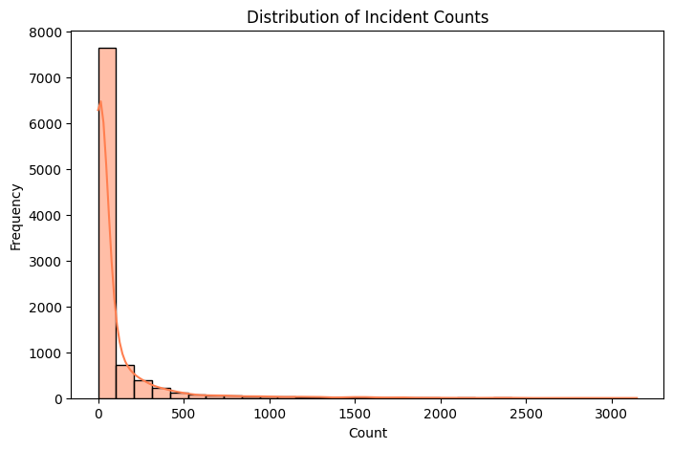
#Accidents per City
plt.figure(figsize=(15,12))
top_cities = df.sort_values('count', ascending=False)
sns.barplot(data=top_cities, y='million_plus_cities', x='count', palette='viridis')
plt.title('Total Accidents City')
plt.xlabel('Total Accidents')
plt.ylabel('City')
plt.show()
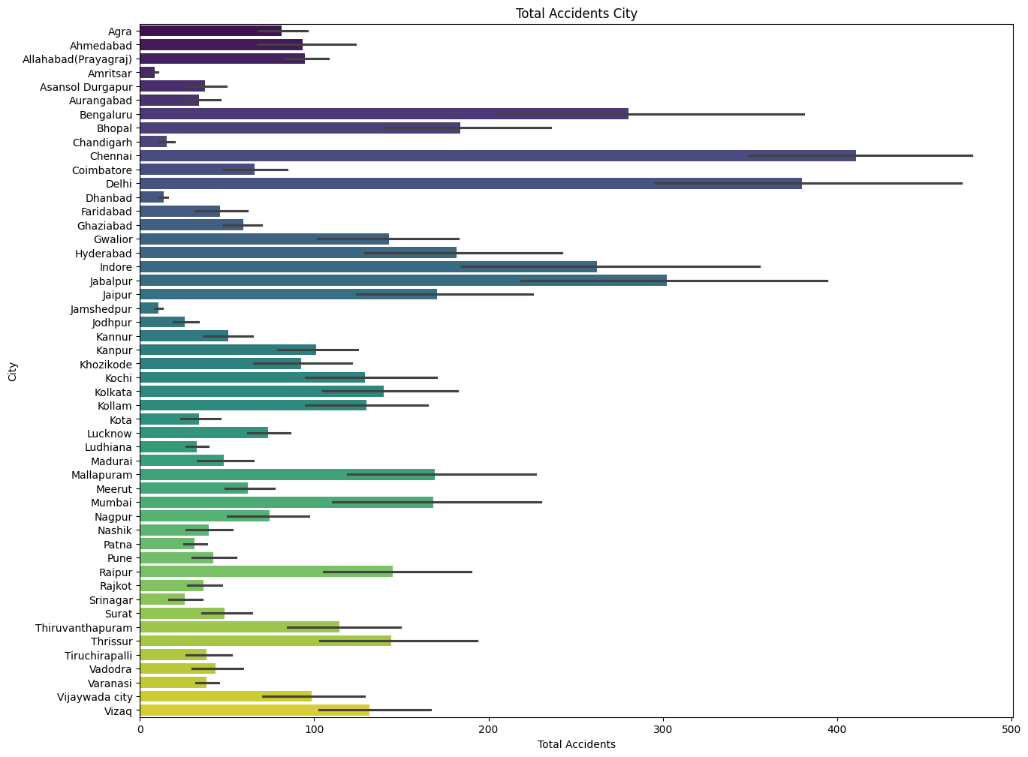
#Chennai,Delhi and Jabalpur are top 3 cities with highest accidents
#Dhanbad,Jamshedpur and Amritsar are cities with least accidents
#Top 10 Cities by Incident Count
city_counts = df.groupby('million_plus_cities')['count'].sum().sort_values(ascending=False)
plt.figure(figsize=(12, 6))
city_counts.head(10).plot(kind='bar', color='teal')
plt.title('Top 10 Cities by Total Incident Count')
plt.ylabel('Total Incidents')
plt.xlabel('City')
plt.show()

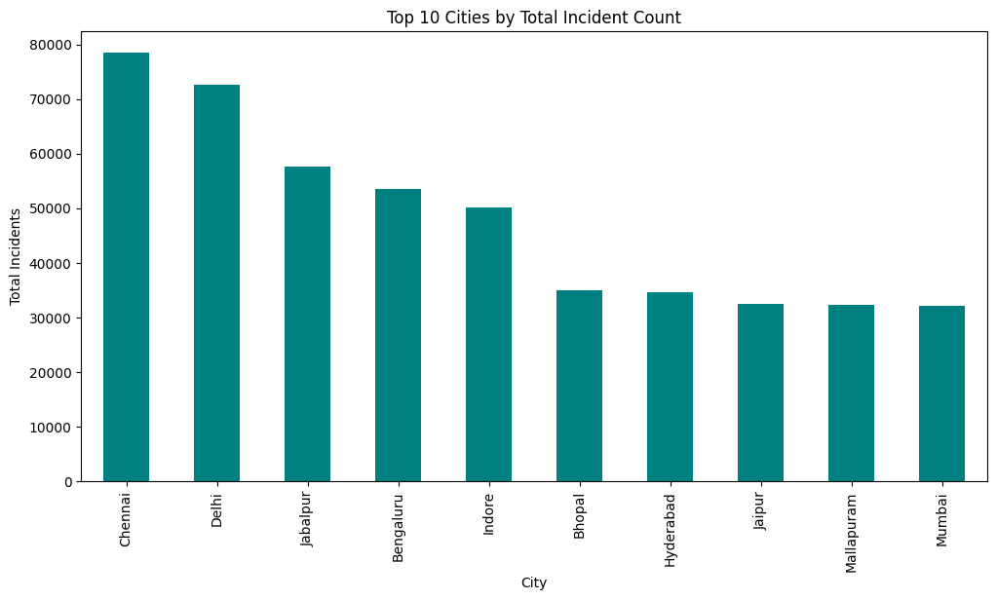
#Top 10 Cities by Incident Count
city_counts = df.groupby('million_plus_cities')['count'].sum().sort_values(ascending=True)
plt.figure(figsize=(12, 6))
city_counts.head(10).plot(kind='bar', color='coral')
plt.title('Top 10 Cities by Total Incident Count')
plt.ylabel('Total Incidents')
plt.xlabel('City')
plt.show()
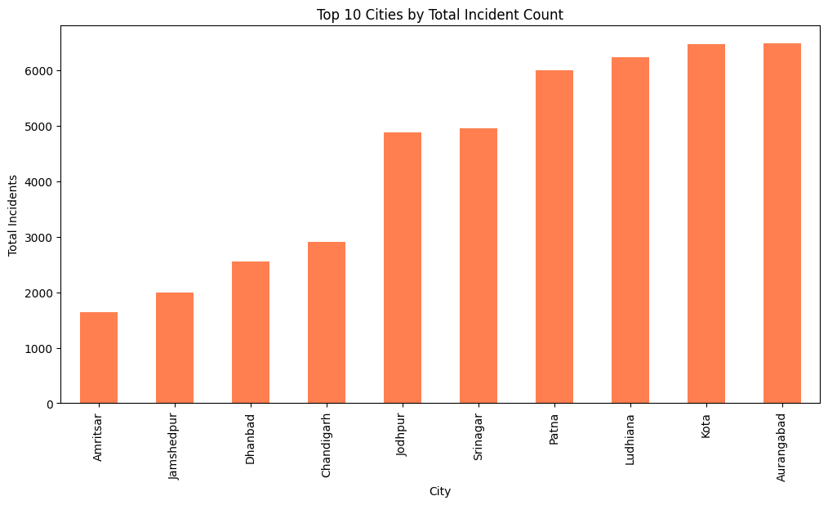
#Incident Count by Cause Category
sns.countplot(data=df,x="cause_category")
plt.xticks(rotation=90)
plt.show()
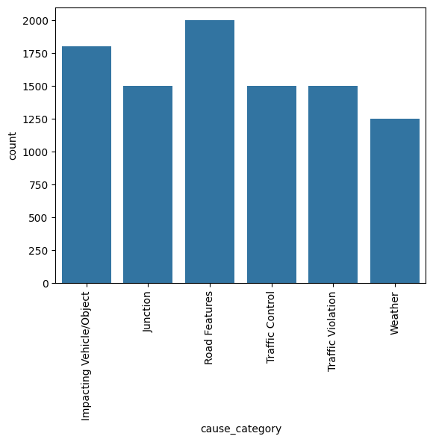
#Incident Count by Cause Subcategory
cause_subcategory_counts = df.groupby('cause_subcategory')['count'].sum().sort_values(ascending=False)
plt.figure(figsize=(14, 6))
cause_subcategory_counts.head(15).plot(kind='bar', color='red')
plt.title('Top 15 Cause Subcategories by Total Incidents')
plt.ylabel('Total Incidents')
plt.xlabel('Cause Subcategory')
plt.xticks(rotation=45, ha='right')
plt.show()

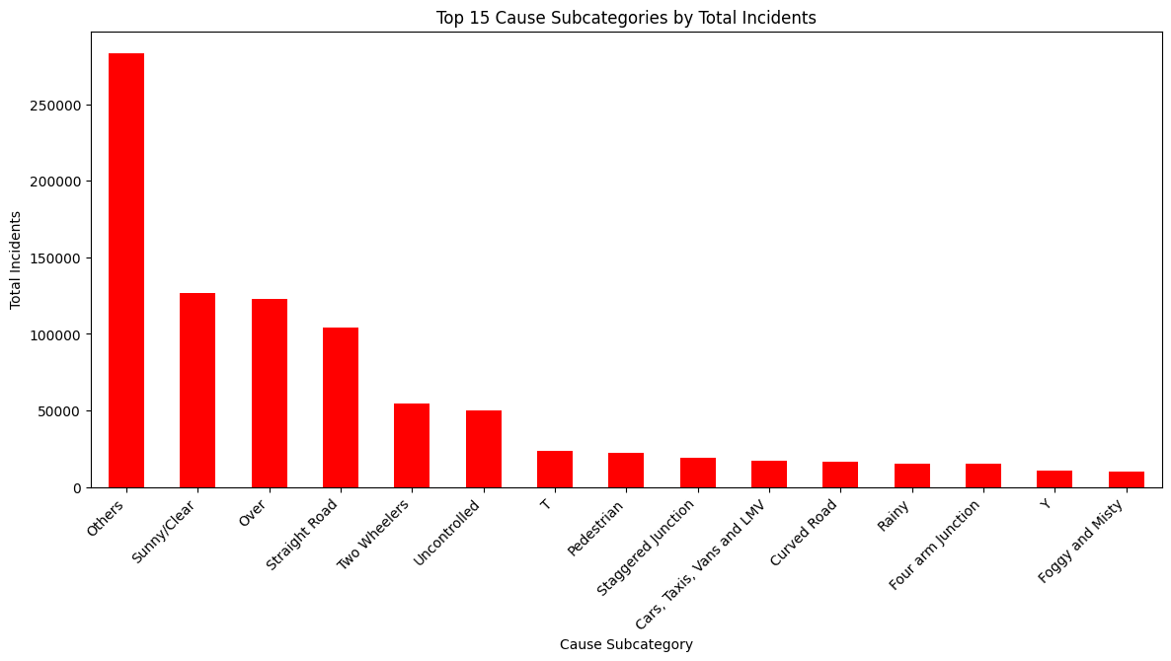
#Outcome of Incident Analysis
outcome_counts = df.groupby('outcome_of_incident')['count'].sum().sort_values(ascending=False)
plt.figure(figsize=(10, 5))
sns.barplot(x=outcome_counts.index, y=outcome_counts.values,hue= outcome_counts, palette='coolwarm')
plt.title('Total Incidents by Outcome of Incident')
plt.ylabel('Total Incidents')
plt.xlabel('Outcome')
plt.xticks(rotation=45)
plt.show()

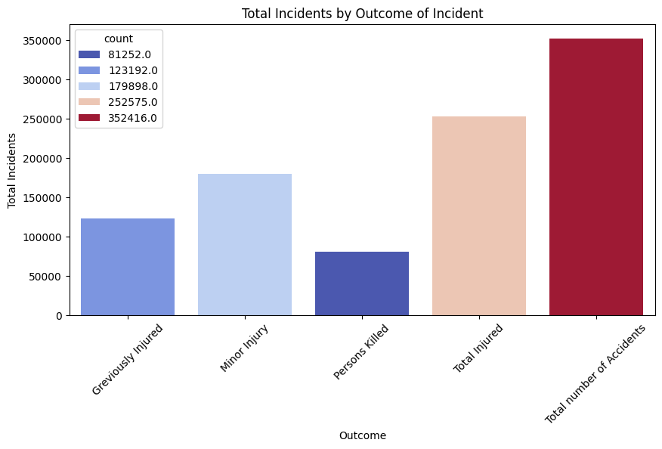
#Heatmap of Causes vs Outcomes
pivot_table = df.pivot_table(values='count',index='cause_category',
columns='outcome_of_incident',
aggfunc='sum',
fill_value=0)
plt.figure(figsize=(12, 8))
sns.heatmap(pivot_table, annot=True, fmt='.0f', cmap='YlGnBu')
plt.title('Heatmap of Cause Category vs Outcome')
plt.ylabel('Cause Category')
plt.xlabel('Outcome of Incident')
plt.show()
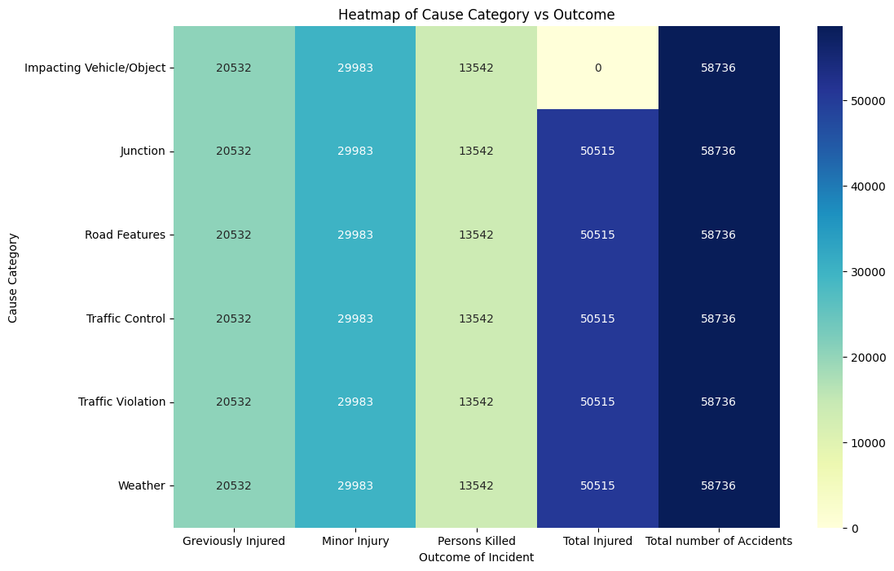
#Heatmap of Cities vs Cause Categories
city_cause_pivot = df.pivot_table(values='count',
index='million_plus_cities',
columns='cause_category',
aggfunc='sum',
fill_value=0)
plt.figure(figsize=(14, 10))
sns.heatmap(city_cause_pivot, cmap='viridis')
plt.title('Heatmap of Cities vs Cause Categories')
plt.ylabel('City')
plt.xlabel('Cause Category')
plt.show()
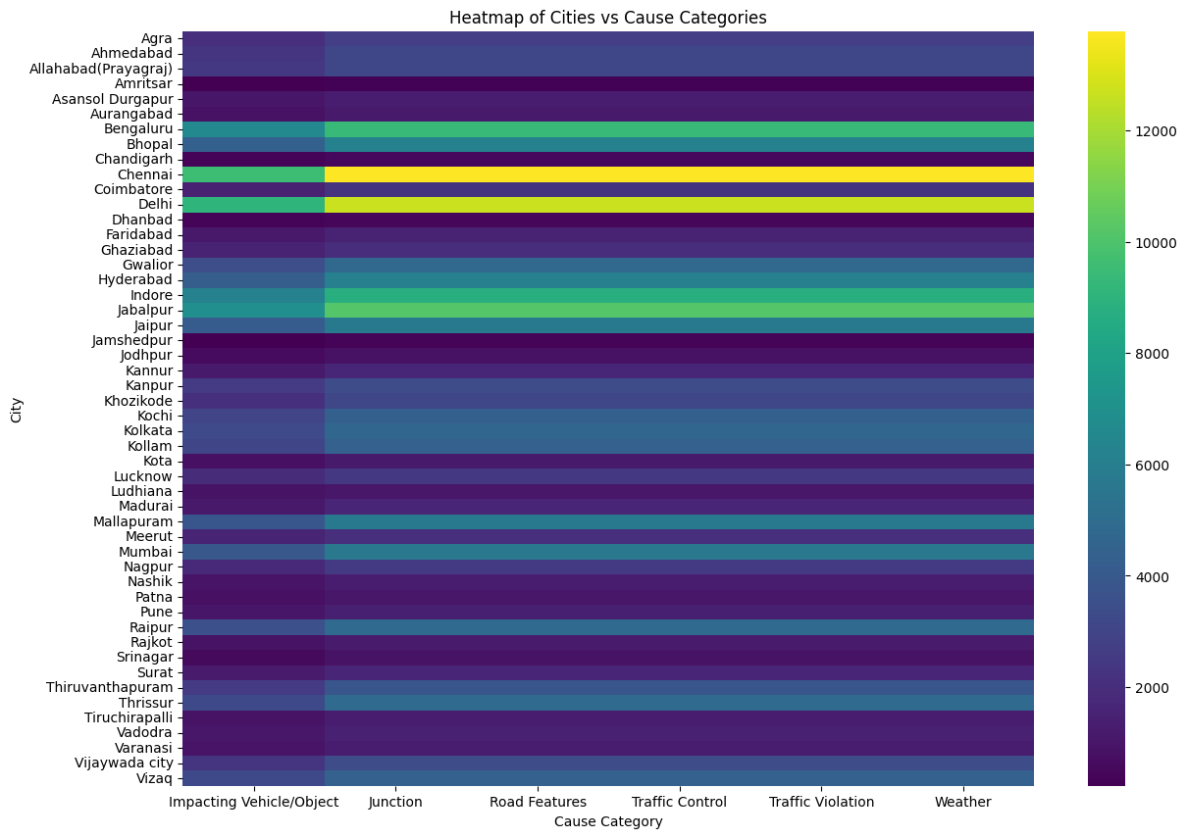
#The top 10 cities account for X% of all incidents
total_incidents = df['count'].sum()
print(f"Total incidents in all cities: {total_incidents}")
Total incidents in all cities: 989333.0
# Group by city, sum incidents
city_totals = df.groupby('million_plus_cities')['count'].sum().sort_values(ascending=False)
print(city_totals)
million_plus_cities
Chennai 78459.0
Delhi 72526.0
Jabalpur 57715.0
Bengaluru 53535.0
Indore 50098.0
Bhopal 35069.0
Hyderabad 34720.0
Jaipur 32524.0
Mallapuram 32294.0
Mumbai 32106.0
Raipur 27722.0
Thrissur 27540.0
Gwalior 27309.0
Kolkata 26715.0
Vizaq 25122.0
Kollam 24821.0
Kochi 24694.0
Thiruvanthapuram 21825.0
Kanpur 19280.0
Vijaywada city 18823.0
Allahabad(Prayagraj) 18066.0
Ahmedabad 17796.0
Khozikode 17696.0
Agra 15483.0
Nagpur 14170.0
Lucknow 14014.0
Coimbatore 12574.0
Meerut 11801.0
Ghaziabad 11319.0
Kannur 9669.0
Surat 9249.0
Madurai 9155.0
Faridabad 8735.0
Vadodra 8292.0
Pune 8018.0
Nashik 7537.0
Tiruchirapalli 7321.0
Varanasi 7303.0
Asansol Durgapur 7164.0
Rajkot 6984.0
Aurangabad 6475.0
Kota 6460.0
Ludhiana 6230.0
Patna 5997.0
Srinagar 4945.0
Jodhpur 4881.0
Chandigarh 2900.0
Dhanbad 2560.0
Jamshedpur 1997.0
Amritsar 1645.0
Name: count, dtype: float64
#Total incidents in top 10 cities
top10_total = city_totals.head(10).sum()
#Compute % share of top 10 cities
top10_share_pct = (top10_total / total_incidents) * 100
print(f"Top 10 cities account for {top10_share_pct:.2f}% of all incidents.")
Top 10 cities account for 48.42% of all incidents.
# Values
top10_share = top10_total
rest_share = total_incidents - top10_total
# Labels and sizes
labels = ['Top 10 Cities', 'Other Cities']
sizes = [top10_share, rest_share]
colors = ['#ff9999','#66b3ff']
# Plot
plt.figure(figsize=(6,6))
plt.pie(sizes, labels=labels, autopct='%1.1f%%', startangle=90, colors=colors, explode=(0.05, 0))
plt.title('Incident Share: Top 10 Cities vs Other Cities')
plt.show()
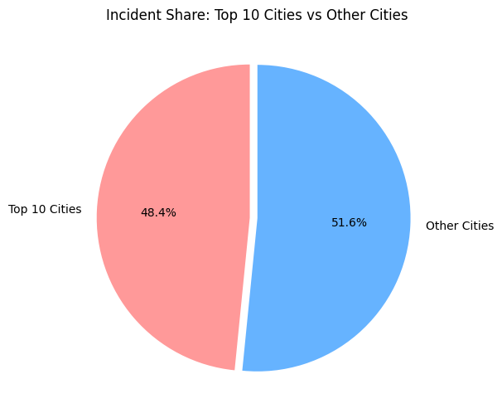

#Conclusion
The analysis reveals that the top 10 million-plus cities together account for approximately 48.42% of all reported incidents in the dataset.
This striking concentration indicates that nearly half of all road incidents occur in just 10 major urban centers,highlighting the need for targeted urban safety interventions.
Among these, Chennai, Delhi, and Jabalpur stand out as the cities with the highest number of accidents,while Dhanbad, Jamshedpur, and Amritsar recorded the lowest.
The data also shows that certain cause categories road features and Impacting vehicle/object—dominate as primary factors behind incidents.
Analysis of outcomes reveals that most incidents result in injuries, underscoring a significant burden on public health systems.
Heatmap visualizations further highlight distinct city-specific patterns in incident causes,
offering valuable guidance for urban planners and policymakers aiming to design targeted, localized safety strategies.

